Maggie Mahoney

Project 4: Restful API

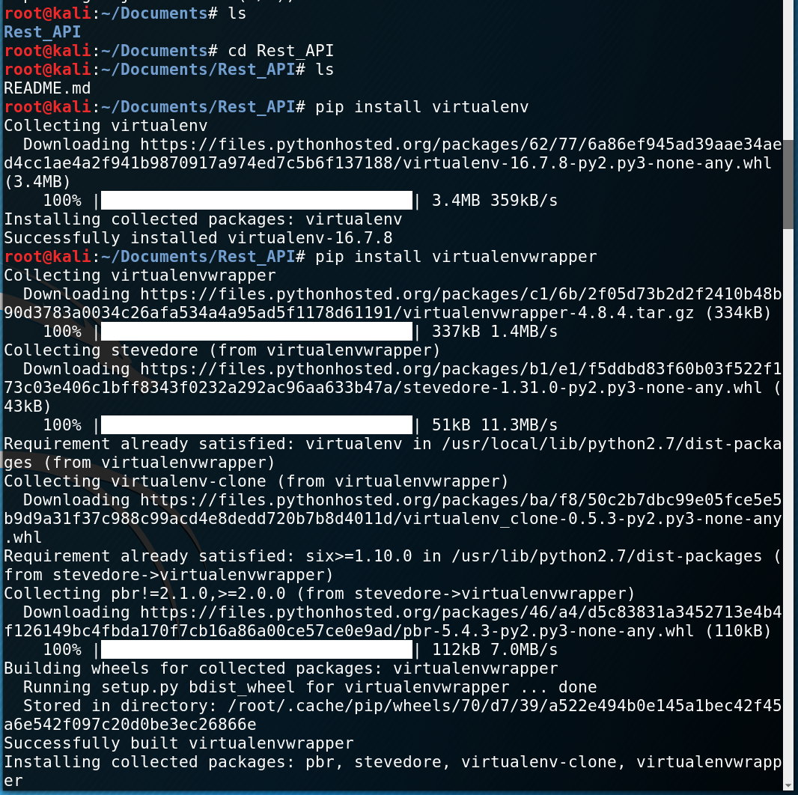I completed the project in a Kali Linux Virtual Machine. The screenshots below show the setting up a virtual environment. The first one shows installing the virtualenv using pip.

The second screenshot shows the end of the virtualenv installation and the creation of the HelloWorld environment.

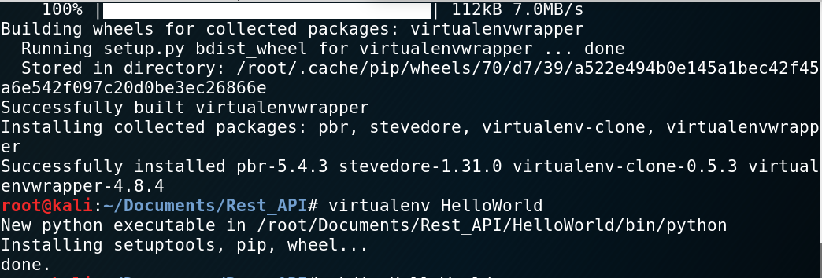

Next, I activated the HelloWorld environment and installed flask using pip.

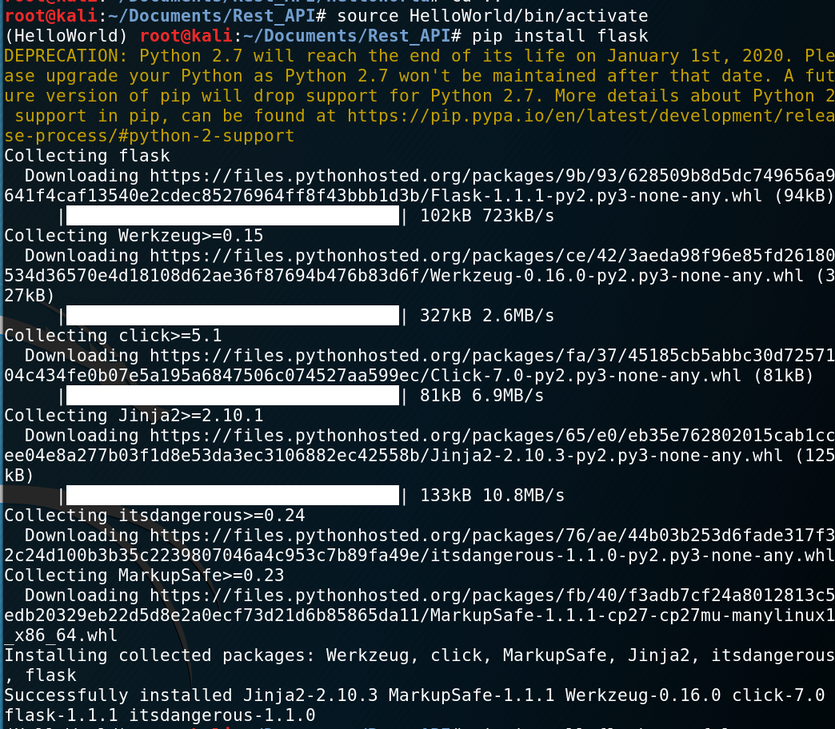

The final step before testing the site was installing flask-restful.

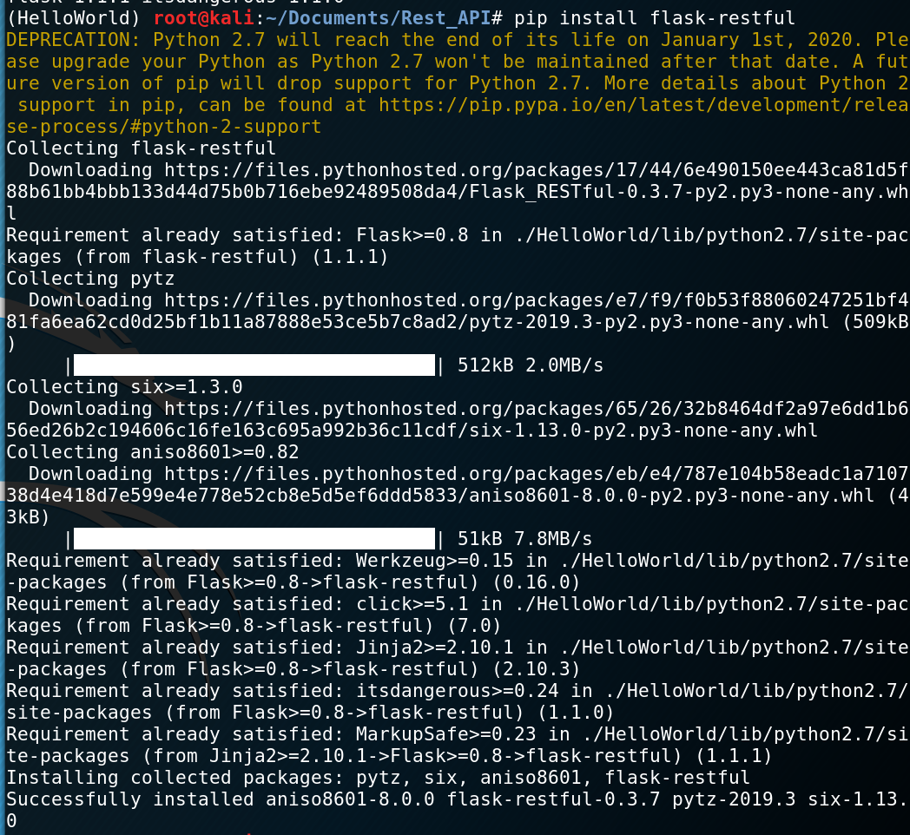

Here is the screenshot of when I went to <http://127.0.0.1:5000>.

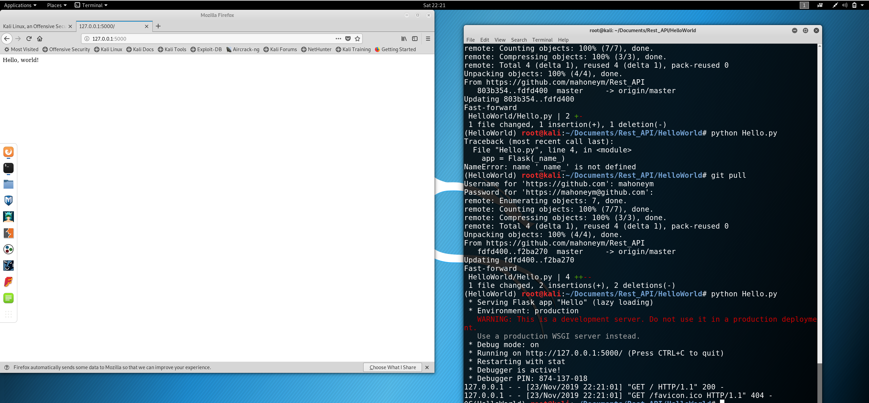

Finally, here are the screenshots of my results when the program ran successfully. The first screenshot below is when I added a user, and the second screenshot is when I got the user back. The final screenshot shows the results of getAllUsers, which should print all users in the list.

